**DAILY ONLINE ACTIVITIES SUMMARY**

|  |  |  |  |  |  |  |  |
| --- | --- | --- | --- | --- | --- | --- | --- |
| **Date:** | **17/06/2020** | | | | **Name:** | **Churashma** | |
| **Sem & Sec** | **4th SEM 'A' Section** | | | | **USN:** | **4AL18CS019** | |
| **Online Test Summary** | | | | | | | |
| **Subject** | | **No test** | | | | | |
| **Max. Marks** | | **-** | | **Score** | | **-** | |
| **Certification Course Summary** | | | | | | | |
| **Course** | **Introduction to information security** | | | | | | |
| **Certificate Provider** | | | **greatlearning academy** | **Duration** | | | **5.5 hours** |
| **Coding Challenges** | | | | | | | |
| **Problem statement 1: Write a Python program to check whether a given a binary tree is a valid binary search tree (BST) or not?**  **Problem statement 2:Write a C Program to Count numbers that don’t contain 3.** | | | | | | | |
| **Status: completed** | | | | | | | |
| **Uploaded the report in Github** | | | | **yes** | | | |
| **If yes Repository name** | | | | **https://github.com/Churashma/Lockdown-coding** | | | |
| **Uploaded the report in slack** | | | | **yes** | | | |

ONLINE TEST DETAILS: No test.

CERTIFICATION COURSE DETAILS: Today I studied about Introduction to Software security lesson 2 and also I studied about security lessons from big name breaches.Worms spread from computer to computer, but unlike a virus, it has the capability to travel without any help from a person.A Trojan horse is not a virus. It is a destructive program that looks as a genuine application. Unlike viruses, Trojan horses do not replicate themselves but they can be just as destructive.

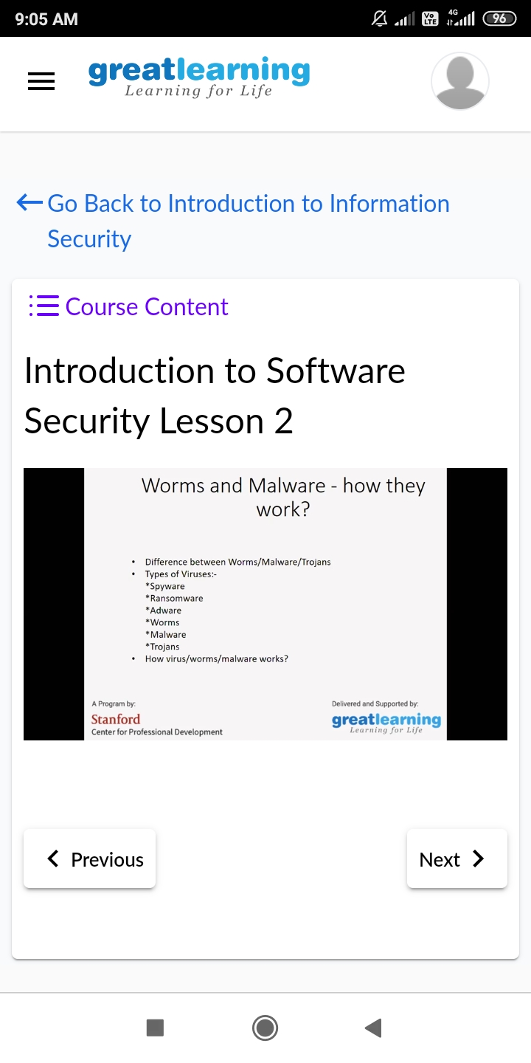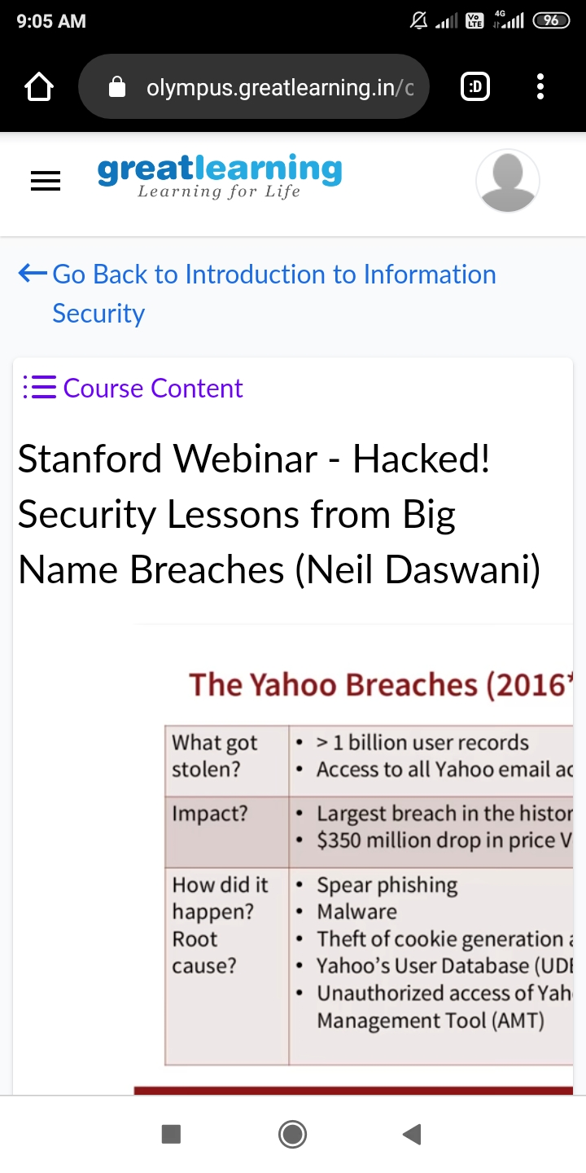

**CODING CHALLENGES DETAILS**:

**Problem statement 1:**  Write a Python program to check whether a given a binary tree is a valid binary search tree (BST) or not?

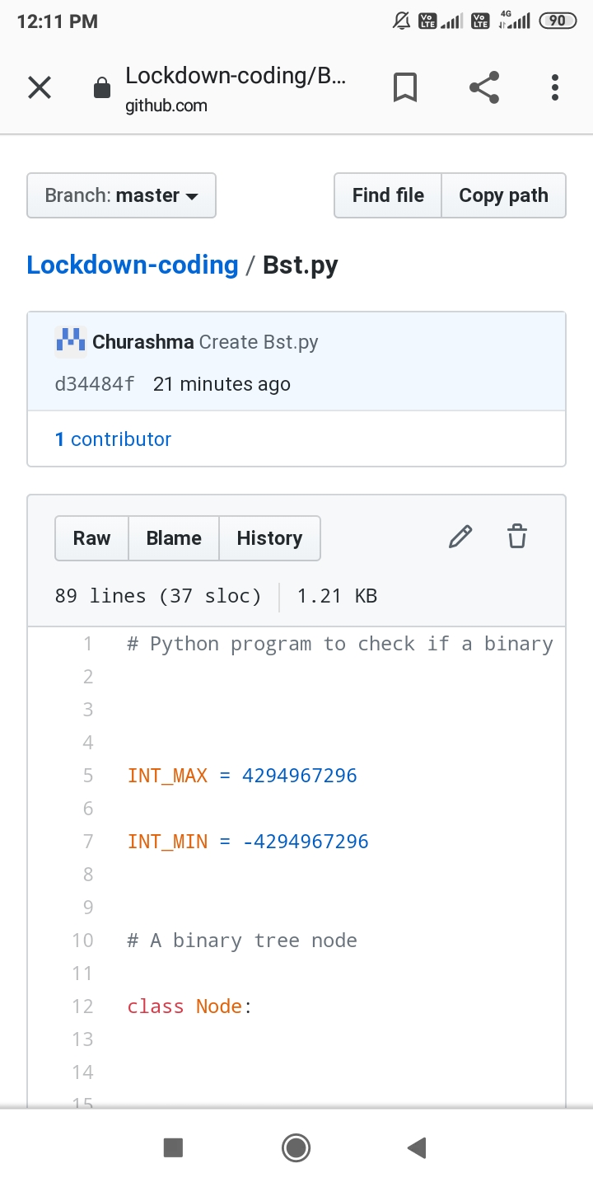

Problem statement 2: Write a C Program to Count numbers that don’t contain 3.

